Connecting to Staff Wireless on a Mac:

- Click on the wireless icon located in the upper right hand corner of the screen. It is the icon highlighted above.

- Click on Join Other Network.

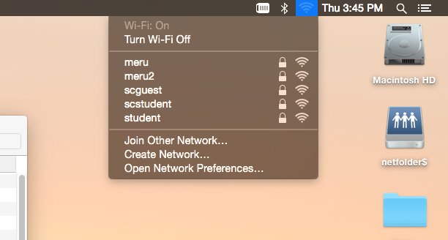

- Enter the network name of Staff and to choose WPA2 in the security drop down.

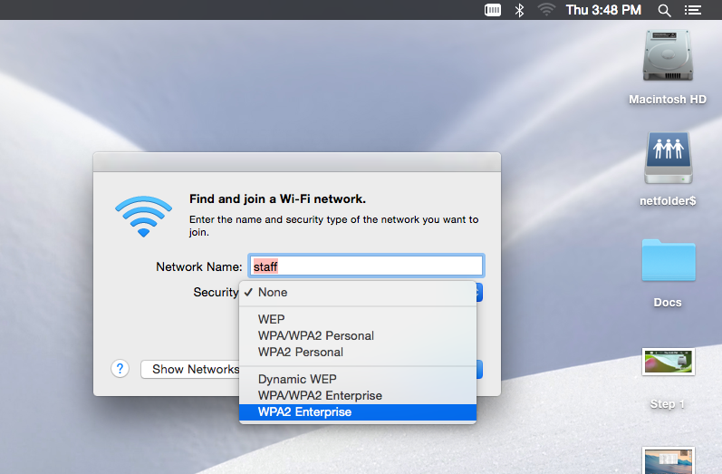

- Enter your username and password and then click Join.
